Name: |  |  |  |  | DOB: | Student  Photo
School: |  |  | Homeroom/Teacher:

Allergy to: |  |  |  | (Do separate order if both insect and food allergy)
Asthma: | Yes* No |  | *Higher Risk for severe reaction

Extremely reactive to the following:
If checked, give epinephrine immediately for ANY symptoms if the allergen was likely (eaten or stung).
If checked, give epinephrine immediately if the allergen was definite (eaten or stung) even if not symptoms are noted.

Any SEVERE SYMPTOMS after suspected or known ingestion:  One or More of the following life threatening symptoms: |  |  | 1. INJECT EPINEPHIRNE IMMEDIATELLY  2. Call 911, state that an allergic reaction has been treated, and additional epinephrine may be needed.  3. Monitor student  4. Give additional medications*  - Antihistamine  - Inhaler (bronchodilator) if ordered for asthma  *Antihistamines & inhaler bronchodilators are not to be depended upon to treat a severe reaction (anaphylaxis).
LUNG: | Short of breath, wheeze, repetitive cough
HEART: | Pale, blue, faint, weak pulse, dizzy, confused
THROAT: | Tight, hoarse, trouble breathing/swallowing
MOUTH: | Obstructive swelling (tongue &/or Lips)
SKIN: | Many hives over body
Or combination of symptoms from different body areas:
SKIN: | Hives, itchy rashes, swelling (eyes, lips)
GUT: | Vomiting, diarrhea, crampy pain
MILD SYMPTOMS ONLY: |  |  | 1. GIVE ANTIHISTAMINE  2. Stay with student; alert healthcare professionals and parent  3. Monitor student  4. If symptoms become severe use Epinephrine
MOUTH: | Itchy mouth
SKIN: | A few hives around mouth/face, mild itch
GUT: | Mild nausea/discomfort

Physician Medication Order:
Epinephrine: Inject intramuscularly (choose one):  EpiPen® or Adrenaclick™ (0.3mg) student 66 lbs or more  EpiPen® Jr. or Adrenaclick™ (0.15mg) student 33 to 66 lbs) |  |  |  | Auvi-Q (0.15mg)  Auvi-Q (0.3mg)
Antihistamine brand: |  |  | Dose: |  | Route:
Other (e.g., inhaler-bronchodilator): |  |  | Dose: |  | Route:

School Considerations: May Self Carry  Epinephrine must accompany the student if he/she is outside.  Epinephrine must accompany the student if he/she is off school ground (i.e., field trip)  Epinephrine must be available on routine bus ride transportation | Yes  Yes  Yes  Yes | No  No  No  No

Physician Signature*: |  |  |  |  | Date:
Physician Office: |  |  | Phone: |  |  | Fax:

*MD – Please print and sign. Parent to complete their section on back and return to school nurse with medications ordered.

EPIPEN® (EPINEPHRINE) AUTO-INJECTOR DIRECTIONS | 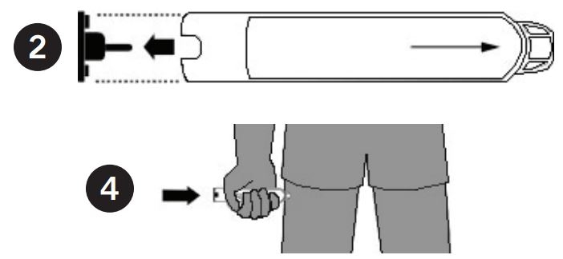
1. Remove the EpiPen Auto-Injector from the plastic carrying case.
2. Pull off the blue safety release cap.
3. Swing and firmly push orange tip against mid-outer thigh.
4. Hold for approximately 10 seconds.
5. Remove and massage the area for 10 seconds.

AUVI-Q™ (EPINEPHRINE INJECTION, USP) DIRECTIONS | 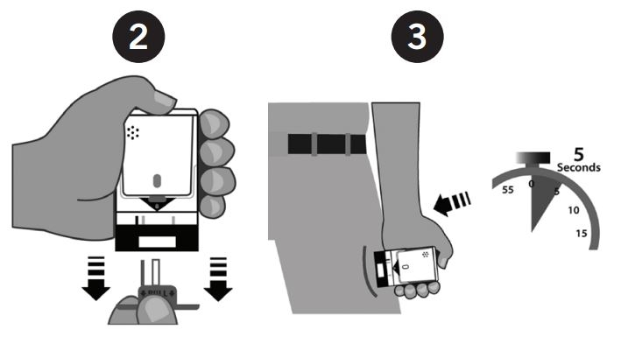
1. Remove the outer case of AUVI-Q. This will automatically activate the voice instructions.
2. Pull off red safety guard.
3. Place black end against mid-outer thigh.
4. Press firmly and hold for 5 seconds.
5. Remove from thigh.

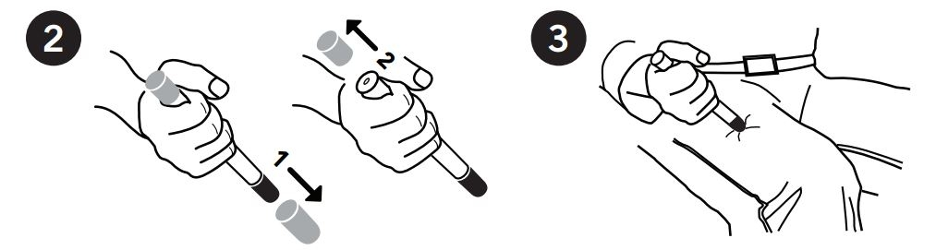
ADRENACLICK®/ADRENACLICK® GENERIC DIRECTIONS
1. Remove the outer case.
2. Remove grey caps labeled “1” and “2”.
3. Place red rounded tip against mid-outer thigh.
4. Press down hard until needle penetrates.
5. Hold for 10 seconds. Remove from thigh.

OTHER DIRECTIONS/INFORMATION (may self carry epinephrine, may self administer epinephrine, etc.):

Treat student before calling Emergency Contacts. The first signs of a reaction can be mild, but symptoms can get worse quickly.
EMERGENCY CONTACTS – CALL 911 |  |  |  |  |  |  |  | OTHER EMERGENCY CONTACTS
Rescue Squad: |  |  |  |  |  |  |  | Name/Relationship:
Doctor: |  |  |  |  | Phone: |  |  | Phone:
Parent / Guardian: |  |  |  |  |  |  |  | Name/Relationship:
 |  |  |  |  | Phone: |  |  | Phone:

Parent/Guardian Authorization Signature |  | Date

